

**Figure S1.** Mean (± SE) values of environmental variables among habitats (**a-d**) and soil types (**e-g**) sampled at Shipley Skinner Reserve. Soil habitats: chaparral (CHA), coastal scrub sage (CSS), native grass (NGR), holly-leaf cherry (HLC), oak woodland (OWL), and riparian (RIP). KW statistical tests and p-value for comparisons between soil types are provided in Table S4.

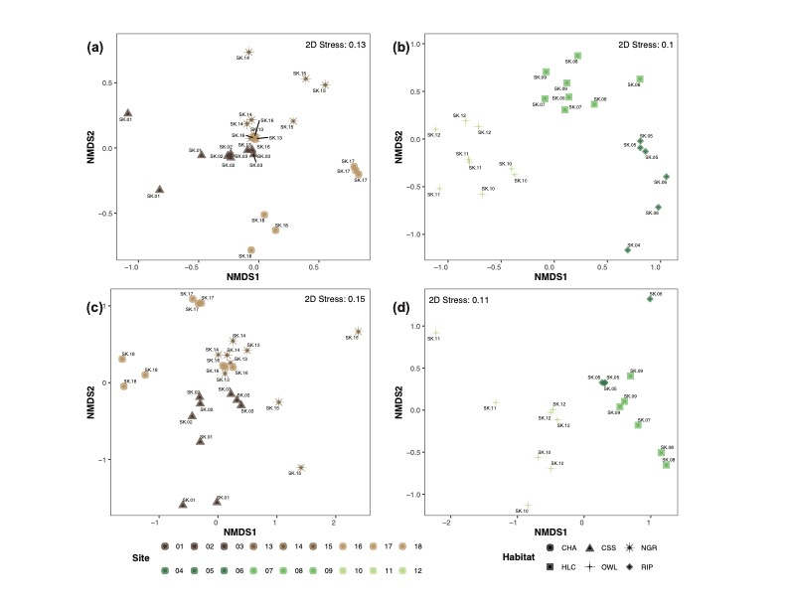

**Figure S2.** nMDS ordinations of (**a-b**) bacterial/archaeal and (**c-d**) eukaryotic soil communities showing grouping by sampling sites within habitats for each soil type separately. nMDSs are based on the Bray-Curtis similarity constructed from the relative abundance of AVSs (square root transformed). Soil habitats: chaparral (CHA), coastal scrub sage (CSS), native grass (NGR), holly-leaf cherry (HLC), oak woodland (OWL), and riparian (RIP).



**Figure S3.** Soil microbial and eukaryotic community composition at different soil habitats. (**a-c**) Phylum, class, and order level classification for bacteria/archaea, respectively. (**d-f**) Major eukaryotic groups, metazoan phyla, and fungal order level classification, respectively. Low abundance taxa were grouped into the “Others” category. Relative abundance of taxa contributing to ≥5% is displayed on the barplots. Soil habitats: chaparral (CHA), coastal scrub sage (CSS), native grass (NGR), holly-leaf cherry (HLC), oak woodland (OWL), and riparian (RIP).



**Figure S4.** Heatmap of differentially abundant microbial genera across soil habitats within compacted and uncompacted soil types. Samples are ordered using hierarchical cluster analysis. The abundance of microbial taxa was transformed using the centered-log ratio (CLR). Green colors indicate high abundance whereas brown colors indicate low abundance. Total read count is also provided for each taxon. Soil habitats: chaparral (CHA), coastal scrub sage (CSS), native grass (NGR), holly-leaf cherry (HLC), oak woodland (OWL), and riparian (RIP).



**Figure S5.** Heatmap of differentially abundant eukaryotic taxa across soil habitats within compacted and uncompacted soil types. Samples are ordered using hierarchical cluster analysis. The abundance of microbial taxa was transformed using the centered-log ratio (CLR). Green colors indicate high abundance whereas brown colors indicate low abundance. Total read count is also provided for each taxon. Soil habitats: chaparral (CHA), coastal scrub sage (CSS), native grass (NGR), holly-leaf cherry (HLC), oak woodland (OWL), and riparian (RIP).



**Figure S6.** Nematode families, genera, and feeding group classifications recovered from morphological/Sanger sequencing (**a-c**) and 18S rRNA soil metabarcoding datasets (**d-f**), respectively. Soil habitats: chaparral (CHA), coastal scrub sage (CSS), native grass (NGR), holly-leaf cherry (HLC), oak woodland (OWL), and riparian (RIP)



**Figure S7.** 10 most dominant microbial taxa in the nematode-associated microbiome sampled at different sampling sites, habitats, and soil types. The relative abundance of microbial taxa for each sampling site is based on 30 nematode specimens. Soil habitats: chaparral (CHA), coastal scrub sage (CSS), native grass (NGR), holly-leaf cherry (HLC), oak woodland (OWL), and riparian (RIP).